**Simple calculator using servlet**

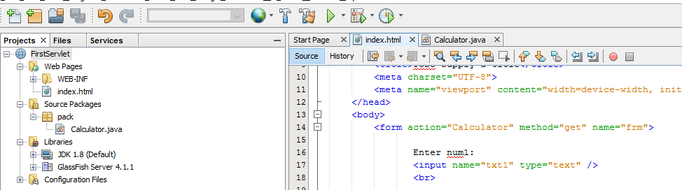

**File name: index.html**

<html>

<head>

<title>TODO supply a title</title>

<meta charset="UTF-8">

<meta name="viewport" content="width=device-width, initial-scale=1.0">

</head>

<body>

**<form action="Calculator" method="get" name="frm">**

**Enter num1:**

**<input name="txt1" type="text" />**

**<br>**

**Enter num2:**

**<input name="txt2" type="text" />**

**<br>**

**Operator**

**<select name="op">**

**<option value="Addition">Addition</option>**

**<option value="Subtraction">Subtraction</option>**

**<option value="multiplication">multiplication</option>**

**<option value="division">division</option>**

**</select>**

**<br>**

**<input type="submit" value="submit" />**

**</form>**

</body>

</html>

**File name: Calculator.java**

package pack;

import java.io.IOException;

import java.io.PrintWriter;

import javax.servlet.ServletException;

import javax.servlet.http.HttpServlet;

import javax.servlet.http.HttpServletRequest;

import javax.servlet.http.HttpServletResponse;

public class Calculator extends HttpServlet {

@Override

protected void doGet(HttpServletRequest request, HttpServletResponse response)

throws ServletException, IOException {

**PrintWriter out = response.getWriter();**

**String n1 = request.getParameter("txt1");**

**String n2 = request.getParameter("txt2");**

**String op = request.getParameter("op");**

**if(op.equals("Addition")){**

**out.println((Integer.parseInt(n1) + Integer.parseInt(n2)));**

**}**

**else if(op.equals("Subtraction")){**

**out.println(Integer.parseInt(n1) - Integer.parseInt(n2));**

**}**

**else if(op.equals("multiplication")){**

**out.println(Integer.parseInt(n1) * Integer.parseInt(n2));**

**}**

**else{**

**out.println(Integer.parseInt(n1) / Integer.parseInt(n2));**

**}**

}

@Override

public String getServletInfo() {

return "Short description";

}

}

**Output:**

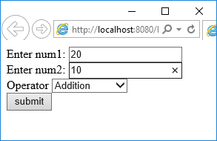 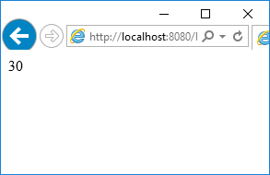

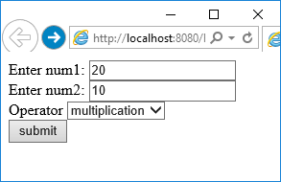 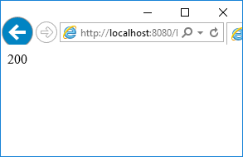

**Login page using servlet**

**File name: index.html**

<html>

<head>

<title>TODO supply a title</title>

<meta charset="UTF-8">

<meta name="viewport" content="width=device-width, initial-scale=1.0">

</head>

<body>

**<form action="Login" method="post" name="frm">**

**Enter Username:**

**<input name="txt1" type="text" />**

**<br>**

**Enter password:**

**<input name="txt2" type="text" />**

**<br>**

**<input type="submit" value="Login" />**

**</form>**

</body>

</html>

**File name: Login.java**

package pack;

import java.io.IOException;

import java.io.PrintWriter;

import javax.servlet.ServletException;

import javax.servlet.http.HttpServlet;

import javax.servlet.http.HttpServletRequest;

import javax.servlet.http.HttpServletResponse;

public class Login extends HttpServlet {

@Override

protected void doPost(HttpServletRequest request, HttpServletResponse response)

throws ServletException, IOException {

**PrintWriter out = response.getWriter();**

**String n1 = request.getParameter("txt1");**

**String n2 = request.getParameter("txt2");**

**if(n1.equals("abc") && (n2.equals("abc123"))){**

**out.println("WELCOME " +n1);**

**}**

**else**

**{**

**out.println("INCORRECT USERNAME AND PASSWORD ");**

**}**

}

@Override

public String getServletInfo() {

return "Short description";

}

}

**Output:**

